A1346-ME-Syro-Hittite-Figurine-Anthropomorphic Bird-Pillar Base-2800 – 1900 BCE

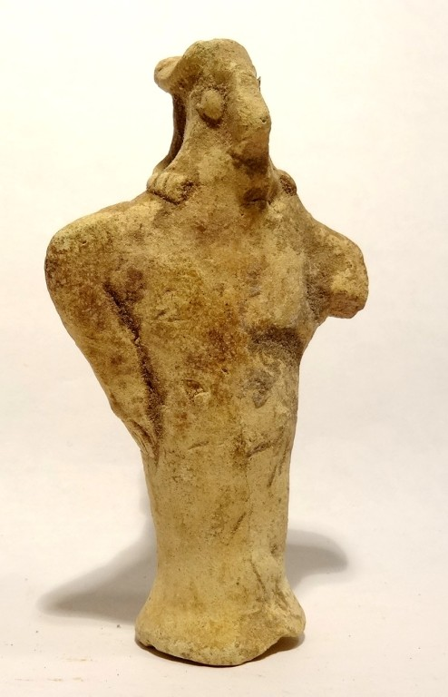 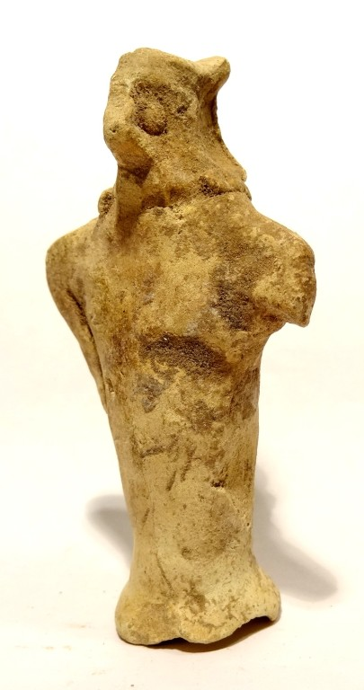 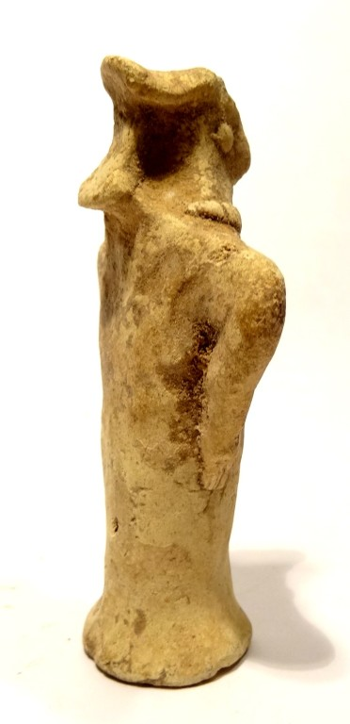 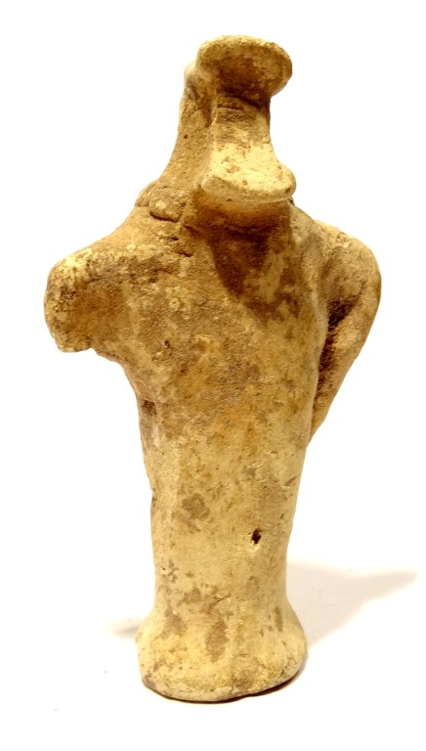 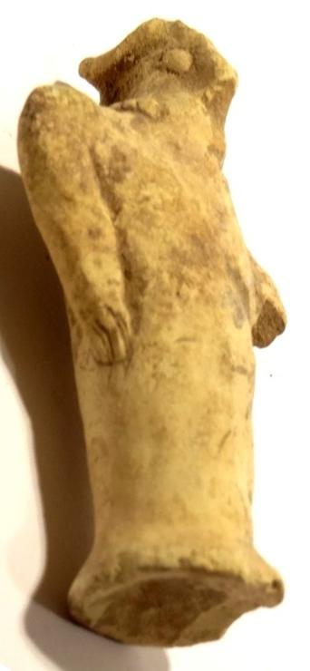

Figs. 1-5. Syro-Hittite-Figurine-Anthropomorphic Raptor-Pillar Base-2800 – 2600 BCE

Case 2

Accession Number: A1346

Formal Label: Syro-Hittite-Figurine-Anthropomorphic Raptor-Pillar Base-2800 – 2600 BCE

Display Description:

Syro-Hittites were Luwian, Aramaic and Phoenician ethno-linguistic groups in northern Syria and southern Anatolia. This Syro-Hittite ceramic figurine with a solid pillar base has a pointed beak like a raptor and pellet shaped eyes suggestive of its superior vision. However, its arms akimbo, positioned like wings and its necklace suggests it is anthropomorphic. Therefore it is implied that this is a shamanic transformation in process.

**LC Classification: BL1605 A5**

Date or Time Horizon: 2800-2600 BCE

Geographical Area: n Syria- s Anatolia

**Map, GPS coordinates:**

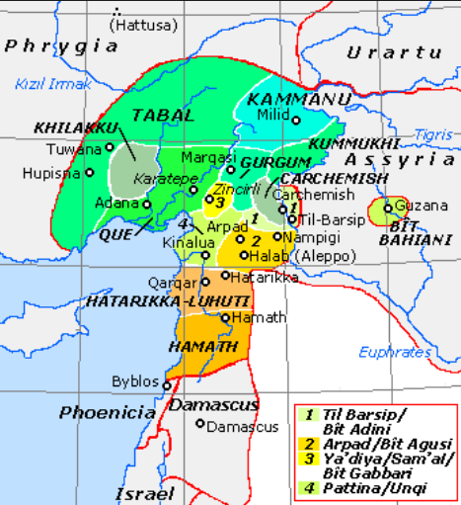

Fig. 6. Map of Luwian-, Aramaic- and Phoenician-speaking political entities of the the Syro-Hittite states in northern Syria and southern Anatolia from https://upload.wikimedia.org/wikipedia/commons/f/fe/NeoHittiteStates.gif.

Cultural Affiliation:Syro-Hittite

Medium: Terracotta

Dimensions: H 78 mm

Weight:

**Condition**: Left lower arm is missing, else very good. Hard and attractive patina, with calcareous adhesions.

Provenance: Eloi Renaud 62 route d'assevent rousies, Nord-Pas-de-Calais 59131, France.

**Discussion:**

This anthropomorphic bird figurine may be model of a vulture priest who would prepare the body for this event. At Çatal Hüyük in south central Anatolia (Turkey) the excarnation ritual is depicted on the walls of its vulture shrines ca 6500 BCE. This could be a shamanic participant in this ritual.

Among the Syro-Hittite peoples the deceased were put on scaffolds or left in the open to allow raptors like the vulture, the hawk and the owl to consume the body of the deceased (excarnation) in order to assume its spirit and wisdom. Excarnation was a world-wide phenomenon.

**References:**

Cornelius, Izak. 2004. *The many faces of the goddess: the iconography of the Syro-Palestinian goddesses Anat, Astarte, Qedeshe.* Fribourg, Switzerland: Academic Press; Göttingen: Vandenhoeck & Ruprecht.

Keel, O. 2008. *Gott weiblich: Eine verborgene Seite des biblischen Gottes, Gutersloher Verlagshaus*. Freiburg.

Spycket, A. 2000. *The Human Form Divine. From the Collection of Elie Borowski,* Exh. cat., Jerusalem: Bible Lands Museum.

Sold by [ancient_artonlin...](http://myworld.ebay.com/ancient_artonline) ( [1879](http://feedback.ebay.com/ws/eBayISAPI.dll?ViewFeedback&userid=ancient_artonline) )

Estimated delivery Tuesday, Dec 13, 2016 - Friday, Dec 23, 2016

#### [RARE STATUETTE IDOLE - VALLEE EUPHRATE- SYRO HITTITE 2600 BC - NEAR EASTERN IDOL](http://www.ebay.com/itm/201717385940)

|  |  |
| --- | --- |
| Item price | $175.90 |
| Quantity | 1 |
| Item number | 201717385940 |
| Shipping service | La Poste - Courrier International Prioritaire |